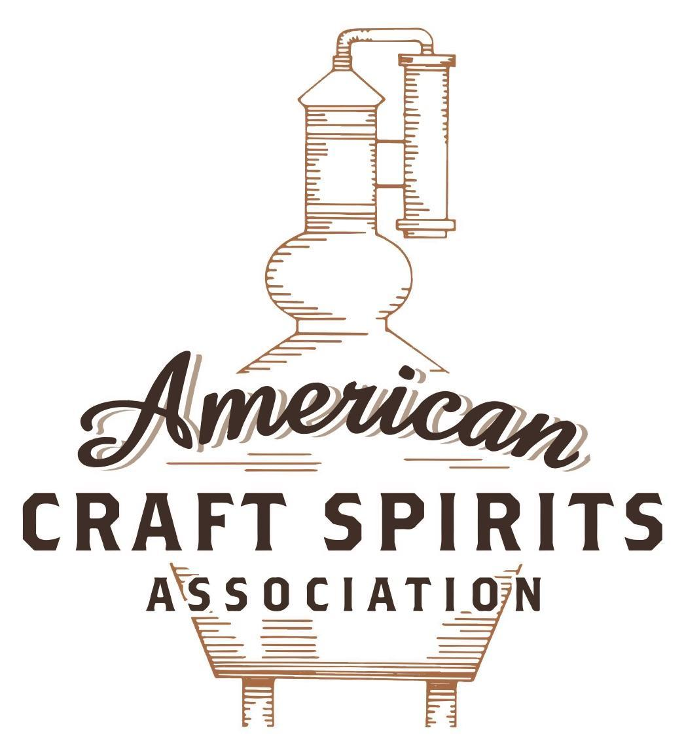
Spirits DtC Shipping Guide

This guide summarizes the direct-to-consumer shipping rules for distilleries in all 50 states and D.C. and also addresses the measures state governments have taken to ease delivery and shipping restrictions during the COVID-19 pandemic.

DtC Quick Guide Comparison

Out-of-State Distilleries  Can Ship Into State? |  |  |  | In-State Distilleries  Can Ship Within State?
State | Yes | No |  | State | Yes | No
AL |  | X |  | AL |  | X
AK | X |  |  | AK | X
AZ | X |  |  | AZ | X
AR |  | X |  | AR |  | X
CA |  | X* |  | CA |  | X*
CO |  | X |  | CO |  | X
CT |  | X* |  | CT |  | X
DE |  | X |  | DE |  | X
DC | X |  |  | DC | X
FL |  | X |  | FL |  | X
GA |  | X |  | GA |  | X
HI |  | X* |  | HI |  | ?*
ID |  | X |  | ID |  | X
IL |  | X* |  | IL |  | X*
IN |  | X |  | IN |  | X
IA |  | X* |  | IA |  | X*
KS |  | X |  | KS |  | X
KY | X |  |  | KY | X
LA |  | X |  | LA |  | X
ME |  | X* |  | ME |  | X*
MD |  | X |  | MD |  | X
MA |  | X |  | MA |  | X
MI |  | X |  | MI |  | X
MN |  | X |  | MN |  | X
MS |  | X |  | MS |  | X
MO |  | X |  | MO |  | X
MT |  | X |  | MT |  | X
NE | X |  |  | NE | X
NV |  | X* |  | NV |  | X
NH | X |  |  | NH |  | X*
NJ |  | X* |  | NJ |  | X*
NM |  | X |  | NM |  | X
NY |  | X* |  | NY |  | X*
NC |  | X |  | NC |  | X
ND | X |  |  | ND | X
OH |  | X |  | OH |  | X
OK |  | X |  | OK |  | X
OR |  | X |  | OR | X
PA |  | X* |  | PA |  | X
RI |  | X* |  | RI |  | X
SC |  | X |  | SC |  | X
SD |  | X |  | SD |  | X
TN |  | X |  | TN |  | X
TX |  | X |  | TX |  | X
UT |  | X |  | UT |  | X
VT |  | X |  | VT |  | X
VA |  | X |  | VA |  | X
WA |  | X* |  | WA | X
WV |  | X* |  | WV |  | X*

WI |  | X |  | WI |  | X
WY |  | X |  | WY |  | X

Notes:
*CA: If passed and signed into law, Senate Bill 620 would allow licensed distilled spirits producers in states other than California and licensed distilled spirits manufacturers or craft distillers in California who obtain distilled spirits direct shipper permits to ship directly to consumers in California
*CT: Consumers with appropriate permit may receive alcohol shipments
*HI: Consumers with appropriate permit may receive alcohol shipments; If passed and signed into law, Senate Bill 65 would allow licensed distilled spirits manufacturers in Hawaii and in states other than Hawaii who obtain direct shipper permits to ship directly to consumers in Hawaii
*IL: If passed and signed into law, Senate Bill 0532 would allow licensed distilled spirits producers in Illinois and in states other than Illinois who obtain distillery shippers’ licenses to ship directly to consumers in Illinois
*IA: If passed and signed into law, House File 639 would allow native distilled spirits manufacturers in Iowa and in states other than Iowa who obtain direct shipper permits to ship directly to consumers in Iowa and to consumers in states other than Iowa
*ME: If passed and signed into law, Legislative Document 1358 would allow distilleries outside of Maine with current manufacturer licenses and distilleries licensed in Maine who obtain spirits direct shipper licenses to ship directly to consumers in Maine
*NJ: (1) If passed and signed into law, Assembly Bill 3167 would allow a craft distillery licensees to ship no more than 9 liters of distilled spirits to a consumer in New Jersey; (2) If passed and signed into law, Senate Bill 3020 would allow craft distillery licensees in New Jersey or in states other than New Jersey to ship no more than 20 liters of distilled spirits to a consumer in New Jersey via common carrier
*NV: Licensed individuals can import one gallon per month of spirits for personal use and the out-of-state supplier must pay excise tax
*NH: If passed and signed into law, Senate Bill 125 would allow licensed liquor manufacturers who obtain direct to consumer shipping permits from the commission to ship directly to consumers in New Hampshire
*NY: Consumer may import up to 90L of liquor per year for personal use without a license; If passed and signed into law, Assembly Bill 3275 would allow licensed liquor manufacturers in states other than New York and licensed distillers and farm distillers in New York to ship no more than thirty-six cases (no more than nine liters per case) of liquor to consumers in New York
*PA: Consumer may place a special liquor order and distiller must ship to a PLCB-operated store
*RI: Distiller can only ship to customer if order was personally placed by customer at distiller's premises
*WA: If passed and signed into law, House Bill 1432 would allow licensed spirits manufacturers in states other than Washington to ship spirits to consumers in Washington
*WV: Distilleries, mini-distilleries, or micro-distilleries licensed in West Virginia or a state other than West Virginia who obtain private direct shipper licenses to ship to a consumer in West Virginia, however the shipments must be made to a retail liquor outlet

NEW JERSEY

Shipment Outbound – Yes, if allowed by the purchaser’s state and local laws (N.J.S.A. 33:1-10, 3a-3d).

Shipment Inbound – No, NJ only allows for wine, cider, or mead to be shipped directly to consumers.

Shipment Intra-state – No, distillers must sell their product to wholesalers and retailers. Only craft distillers may to sell their product at retail to consumers on the licensed premises for consumption on the premises, but only in connection with a tour of the distillery, and for consumption off the premises in a quantity of not more than five liters per person (N.J.S.A. 33:1-10, 3a-3d).

COVID-19 Measures – Craft distilleries may sell to consumers, for off-premises consumption, distilled alcoholic beverages manufactured on its licensed premises that are mixed or blended with other alcoholic or nonalcoholic beverages in closed and sealed containers. Craft distillery licensees may also sell distilled alcoholic beverages that are manufactured on the licensed premises in original containers accompanied by one or more nonalcoholic beverages or food stuffs (such as fruits, vegetables or other garnishes) that may be combined by the consumer to prepare a mixed drink. Any food stuffs sold pursuant to this provision must be sold only as a mixed drink ingredient and not as a separate meal. Containers, other than original in which any distilled alcoholic beverages are mixed or blended with other alcoholic or nonalcoholic beverages cannot exceed a maximum capacity of 16 fluid ounces, inclusive of ice. Any container must be affixed with a tamper evident seal. This act expires on the date of expiration, termination, or recission of any and all executive or administrative orders establishing coronavirus-related restrictions applicable to licensed premises or the first day of the seventh month following the date on which the Governor declares that the state of emergency has ended, whichever date occurs later. The Governor signed Executive Order No. 244 on June 4, 2021 terminating the Public Health Emergency declared in Executive Order No. 103.
Advisory Notice 2020-06 Link: https://www.state.nj.us/lps/abc/downloads/AN_2020-06.pdf
A. 3966 Link: https://www.njleg.state.nj.us/2020/Bills/A4000/3966_U1.PDF
Executive Order No. 244 Link: https://nj.gov/infobank/eo/056murphy/pdf/EO-244.pdf

Citation (shipment)

New Jersey Statutes Annotated

Section: 33:1-10: Class A licenses; subdivisions; fees.
Plenary distillery license. 3a. The holder of this license shall be entitled, subject to rules and regulations, to manufacture any distilled alcoholic beverages and rectify, blend, treat and mix, and to sell and distribute his products to wholesalers and retailers licensed in accordance with this chapter, and to sell and distribute without this State to any persons pursuant to the laws of the places of such sale and distribution, and to maintain a warehouse. The fee for this license shall be $12,500.
Limited distillery license. 3b. The holder of this license shall be entitled, subject to rules and regulations, to manufacture and bottle any alcoholic beverages distilled from fruit juices and rectify, blend, treat, mix, compound with wine and add necessary sweetening and flavor to make cordial or liqueur, and to sell and distribute to wholesalers and retailers licensed in accordance with this chapter, and to sell and distribute without this State to any persons pursuant to the laws of the places of such sale and distribution and to warehouse these products. The fee for this license shall be $3,750.
Supplementary limited distillery license. 3c. The holder of this license shall be entitled, subject to rules and regulations, to bottle and rebottle, in a quantity to be expressed in said license, dependent upon the following fees, alcoholic beverages distilled from fruit juices by such holder pursuant to a prior plenary or limited distillery license, and to sell and distribute his products to wholesalers and retailers licensed in accordance with this chapter, and to sell and distribute without this State to any persons pursuant to the laws of the places of such sale and distribution, and to maintain a warehouse. The fee for this license shall be graduated as follows: to so bottle and rebottle not more than 5,000 wine gallons per annum, $313; to so bottle and rebottle not more than 10,000 wine gallons per annum, $625; to so bottle and rebottle without limit as to amount, $1,250.
Craft distillery license. 3d. The holder of this license shall be entitled, subject to rules and regulations, to manufacture not more than 20,000 gallons of distilled alcoholic beverages, to rectify, blend, treat and mix distilled alcoholic beverages, to sell and distribute this product to wholesalers and retailers licensed in accordance with this chapter, and to sell and distribute without this State to any persons pursuant to the laws of the places of such sale and distribution, and to maintain a warehouse. The holder of this license shall be entitled to sell this product at retail to consumers on the licensed premises of the distillery for consumption on the premises, but only in connection with a tour of the distillery, and for consumption off the premises in a quantity of not more than five liters per person. In addition, the holder of this license may offer any person not more than three samples per calendar day for sampling purposes only. For the purposes of this subsection, "sampling" means the gratuitous offering of an open container not exceeding one-half ounce serving of distilled alcoholic beverage produced on the distillery premises. Nothing in this subsection shall be deemed to permit the direct shipment of distilled spirits either within or without this State.
The holder of this license shall not sell food or operate a restaurant on the licensed premises. A holder of this license who certifies that not less than 51 percent of the raw materials used in the production of distilled alcoholic beverages under this section are grown in this State or purchased from providers located in this State may, consistent with all applicable federal laws and regulations, label these distilled alcoholic beverages as "New Jersey Distilled." The fee for this license shall be $938.
Link: https://njlaw.rutgers.edu/collections/njstats/showsect.php?title=33&chapter=1&section=10&actn=getsect

The American Craft Spirits Association (ACSA) is working diligently to give our members and industry partners relevant, current updates on statutes and regulations impacting production, sale and distribution of spirits. With the declaration of the novel coronavirus (COVID-19) in early 2020, many states have issued temporary policy changes or longer-term modernization of alcohol beverage laws. State statutes, regulations created by the state alcohol regulatory authority, as well as any other relevant guidance provided by such authorities (such as advisories, opinions, bulletins, etc.) were reviewed in creation of this document. No city or county ordinances were reviewed. Distillers should be aware that even in states where direct shipping is permissible, always remember to avoid shipping to dry counties. Please consult with your state guild or alcohol beverage authority for the most up-to-date information. This content is intended for educational and informational purposes only. ACSA's pro bono law firm of Malkin Law P.A. provided the core content found in this comprehensive overview of the spirits distribution after COVID-19. It was completed in August 2021 and will be updated regularly. If you have updates you would like to provide, please send to legislation@americancraftspirits.org or directly to the law firm at: ryan@malkin.law / malkin.law. Thank you.
A. 3167, introduced on February 24, 2020, would allow a holder of a craft distillery license to ship no more than nine liters of distilled spirits per year, subject to regulation, to a consumer in New Jersey who is at least 21 years of age for personal consumption. The bill is in committee. Link: https://www.njleg.state.nj.us/2020/Bills/A3500/3167_I1.HTM S. 3020, introduced on October 19, 2020, would allow a holder of a craft distillery license to ship no more than twenty liters of distilled spirits to a consumer in New Jersey who is at least 21 years of age for personal consumption via common carrier. The bill is in committee. Link: https://www.njleg.state.nj.us/2020/Bills/S3500/3020_I1.HTM
S. 3020, introduced on October 19,2020, would allow a holder of a valid distillery license in a state other than New Jersey who produces no more than 20,000 gallons of distilled alcoholic beverages per year to ship via common carrier or otherwise no more than twenty liters of distilled spirits per year to a consumer in New Jersey who is at least 21 years of age for personal consumption. The bill is in committee. Link: https://www.njleg.state.nj.us/2020/Bills/S3500/3020_I1.HTM

